**New Year's Eve**

As the clock winds down in December, the atmosphere in Sydney becomes electric. The city is getting ready for the biggest party of the year, where more than one million people gather around Sydney Harbour to watch the world-famous fireworks display. It’s a time for locals and visitors to come together and celebrate, to feel nostalgia for the year that was and hope for the year to come.

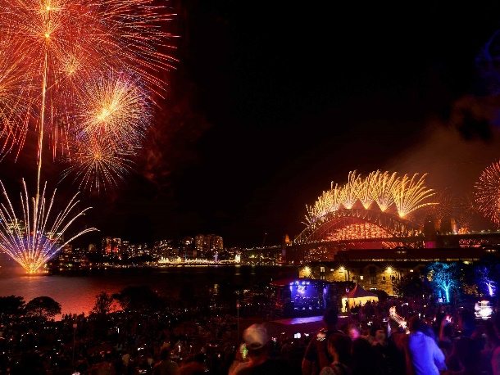

Sydney’s famous New Year’s Eve fireworks show wows audiences around the globe with its captivating display over the harbour. Throughout the day and well into the evening, the city is buzzing with excitement and entertainment in anticipation of the 9pm family fireworks, followed by the midnight spectacular. The fireworks launch from the Harbour Bridge, Sydney Opera House and barges around the harbour.